# Deep learning

Deep learning is subfield of Artificial intelligence and Machine learning. Below are some key aspects of it.

* Inspiration from Human Brain:
  + Deep learning is inspired by the structure and functioning of the human brain. Neural networks, the foundational concept in deep learning, mimic the interconnected neurons in the brain, allowing the system to learn and make decisions.
* Neural Networks:
  + Neural networks are the core of deep learning algorithms. These networks consist of layers of interconnected nodes, organized in input, hidden, and output layers. Each connection between nodes has a weight, and the network learns to adjust these weights during training to make accurate predictions.

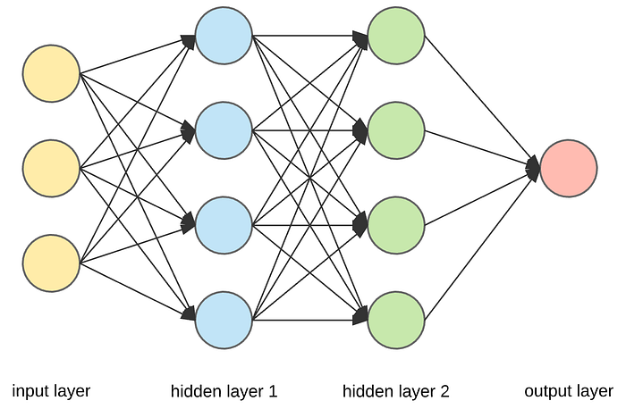

* Machine Learning vs. Deep Learning:
  + While both machine learning and deep learning aim to make predictions based on data, deep learning goes a step further. It involves complex neural network architectures with multiple layers (deep architectures), allowing the system to automatically learn hierarchical features from raw data.
* Types of Neural Networks:
  + Artificial Neural Network (ANN): Basic neural network architecture with input, hidden, and output layers. It's used for a variety of tasks, including regression and classification problems.
  + Convolutional Neural Network (CNN): Designed for tasks involving image and video recognition. CNNs use convolutional layers to automatically and adaptively learn spatial hierarchies of features.
  + Recurrent Neural Network (RNN): Suitable for sequence data, such as time series or natural language. RNNs have loops to allow information persistence, making them effective for tasks involving temporal dependencies.
  + Generative Adversarial Network (GAN): Consists of two networks, a generator and a discriminator, which are trained simultaneously through adversarial training. GANs are widely used for generating new, realistic data, such as images.
* Applications:
  + Deep learning finds applications in various domains, including computer vision, natural language processing, speech recognition, healthcare diagnostics, autonomous vehicles, and more. The ability to automatically learn intricate features from large datasets has led to breakthroughs in many areas.

**Representation Learning in Deep Learning:**

Representation learning is a crucial concept in the realm of machine learning, particularly within deep learning. It refers to the process of allowing a machine learning algorithm to automatically discover and learn the best representation of the data. This stands in contrast to traditional machine learning methods, where manual feature engineering is often required.

In representation learning:

1. **Traditional Machine Learning:**
   * In classical machine learning, human experts need to manually identify and create features from the raw data.
   * Feature engineering involves selecting, transforming, or creating features that are deemed relevant for a particular problem.
2. **Deep Learning:**
   * Deep learning, on the other hand, is designed to automatically learn these representations as part of the training process.
   * Deep neural networks consist of multiple layers, each responsible for learning increasingly abstract and complex features from the raw input data.
   * Lower layers might capture basic features (e.g., edges or textures), while higher layers learn more abstract and sophisticated features, often relevant to human interpretation.

**Comparison: Deep Learning vs. Machine Learning:**

1. **Data Dependency:**
   * Deep Learning: Requires large amounts of data to effectively learn complex representations.
   * Machine Learning: Can operate with smaller datasets for training.
2. **Hardware Requirements:**
   * Deep Learning: Typically relies on GPU processing due to the computational intensity of training deep neural networks.
   * Machine Learning: Can often be implemented on standard CPUs.
3. **Training Time:**
   * Deep Learning: Longer training times due to the complexity of deep neural networks.
   * Machine Learning: Generally shorter training times.
4. **Feature Selection:**
   * Deep Learning: Automatically learns features, eliminating the need for manual feature extraction.
   * Machine Learning: Relies on human-defined features through feature engineering.
5. **Interpretability:**
   * Deep Learning: Often considered a "black box" as it may be challenging to interpret how specific features lead to a particular decision.
   * Machine Learning: Offers more interpretability as feature engineering is explicitly performed by humans.

**History of Deep Learning:**

1. **1960s: Perceptron and AI Winter**
   * In the 1960s, computer science research saw the development of the perceptron, an early form of artificial neural network. Frank Rosenblatt introduced the perceptron and suggested its similarity to the human brain.
   * The first AI winter occurred in 1969 when Marvin Minsky and Seymour Papert pointed out the limitations of perceptrons, notably their inability to learn non-linear functions, such as the XOR function.
2. **1980s: Backpropagation**
   * In 1986, Geoffrey Hinton, along with David Rumelhart and Ronald Williams, introduced the backpropagation algorithm. This innovation allowed neural networks to adjust their weights during training, making it feasible for them to learn complex patterns and non-linear functions.
3. **1989: Convolutional Neural Networks (CNNs)**
   * Yann LeCun, often regarded as the "father of CNNs," introduced this architecture in 1989. CNNs gained prominence for their effectiveness in tasks such as recognizing handwritten ZIP codes.
4. **1990s to 2010s: Limited Progress**
   * The field experienced limited progress during this period, partly due to computational limitations and insufficient labeled datasets.
5. **2012: ImageNet Breakthrough**
   * In 2012, a pivotal moment occurred when a deep learning model, implemented by AlexNet (led by Alex Krizhevsky and Geoffrey Hinton), significantly reduced the error rate in the ImageNet Large Scale Visual Recognition Challenge from 28% to 16%.
   * The utilization of GPUs for training accelerated the progress of deep learning models.
6. **Rapid Advancements and Industrial Adoption**
   * Following the ImageNet breakthrough, numerous mega-companies, including Google, Facebook, and Microsoft, heavily invested in deep learning research.
   * Various frameworks, such as TensorFlow and PyTorch, were developed, making it more accessible for researchers and practitioners to implement and experiment with deep learning models.

**Applications of Deep Learning:**

1. **Self-Driving Cars:**
   * Deep learning is employed in the development of self-driving cars, allowing them to perceive and navigate their environment autonomously. Notable examples include Tesla's Autopilot.
2. **Game-Playing Agents:**
   * Deep learning has been used to train agents that excel in playing complex games. An example is AlphaGo, a program developed by DeepMind, which defeated human champions in the game of Go.
3. **Virtual Assistants and Chatbots:**
   * Natural Language Processing (NLP) powered by deep learning has enhanced virtual assistants and chatbots, enabling more natural and context-aware interactions.
4. **Image Colorization:**
   * Deep learning models are utilized for image colorization, automatically adding color to black and white images.
5. **Audio-Video Processing:**
   * Deep learning is applied to tasks like adding audio to mute videos, generating captions for images, and translating text.
6. **Pixel Restoration:**
   * Restoration of damaged or distorted images using deep learning models that learn to fill in missing or corrupted pixels.

The history and applications of deep learning highlight its transformative impact on various domains, making it a powerful tool for solving complex problems and advancing technology.